Layout voor Huisapotheek

# Components

* **Buttons**

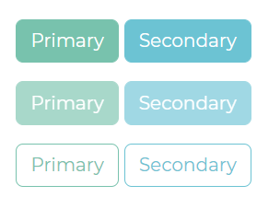

* **Alerts**

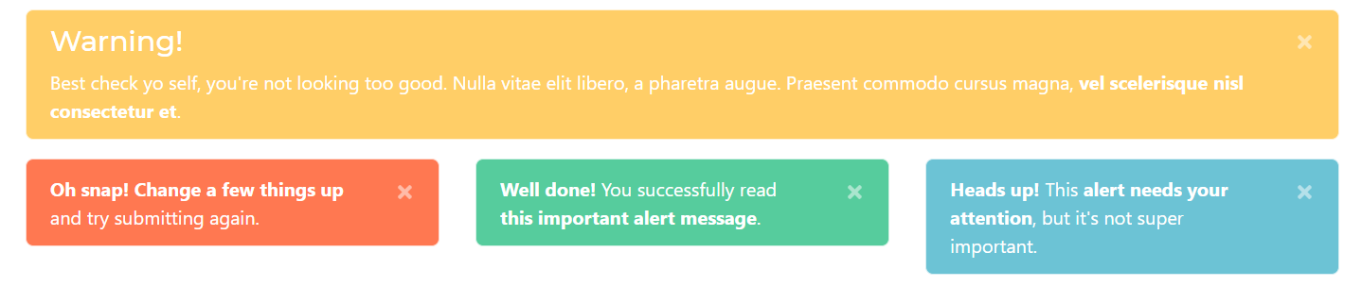

* **Navbar**



* **Forms and input groups**

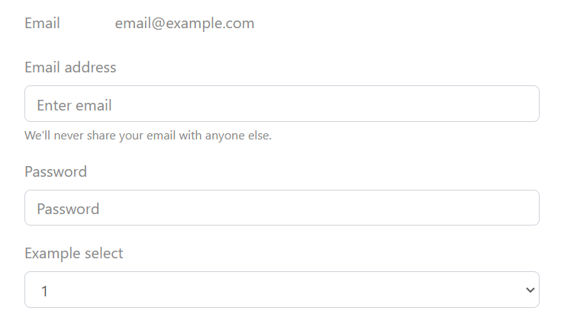

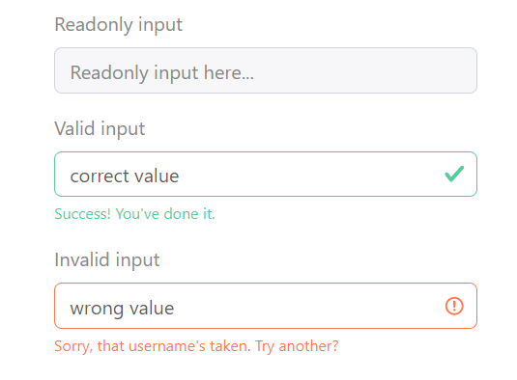

* **Jumbotron**

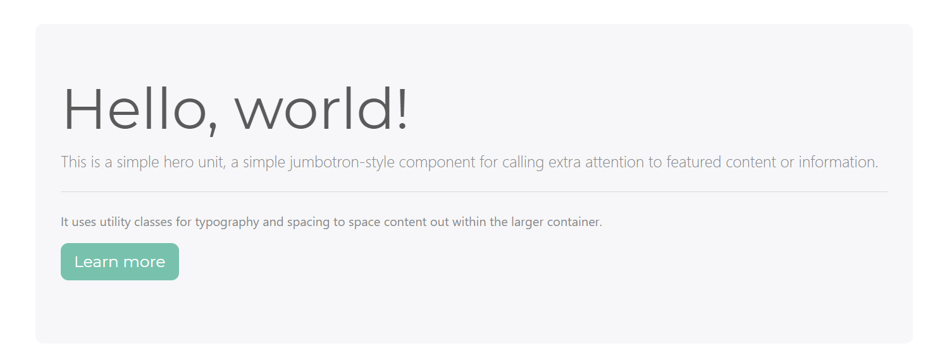

* **Tabs**

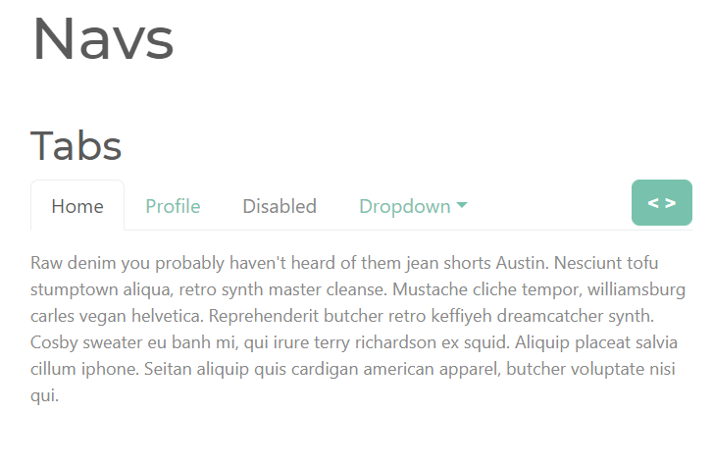Kleuren

* **Primary colors**
  + **--primary-color-green: #56cc9d;**
  + **--primary-color-blue: #6cc3d5;**
  + **--primary-color-white: #fff;**
* **Secundary colors**
  + **Secundary-color-blue: #6cc3d3**